# Develop The Web Application Using Node-RED

1. To Develop the web application using Node-RED

Steps :

1. Open a Node-RED project

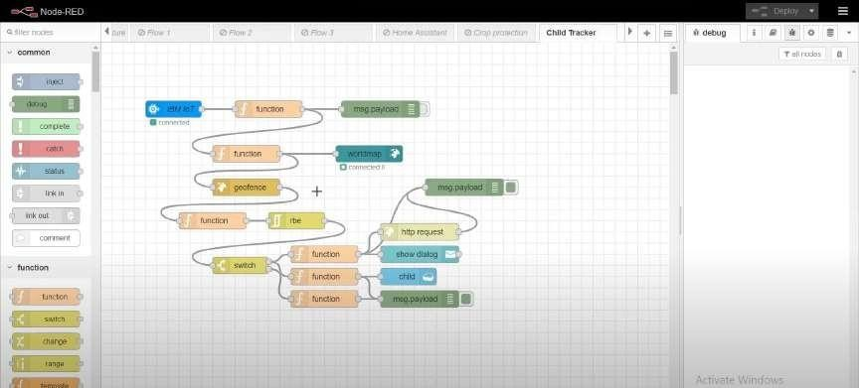

1. Add code to get child location in python

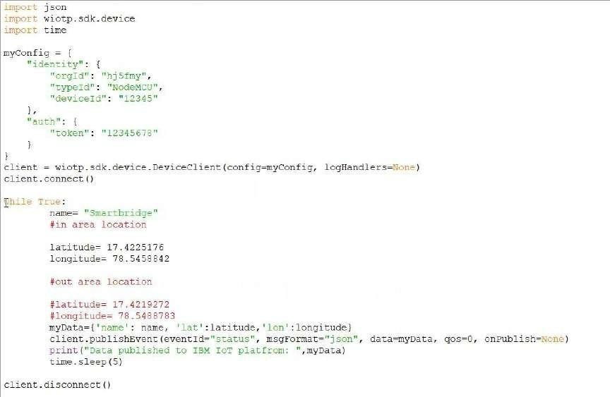

1. Create the GeoFence

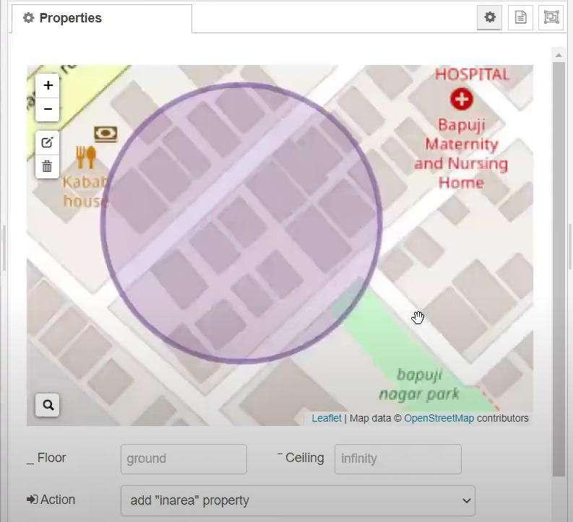

1. Edit the HTTP Request URL

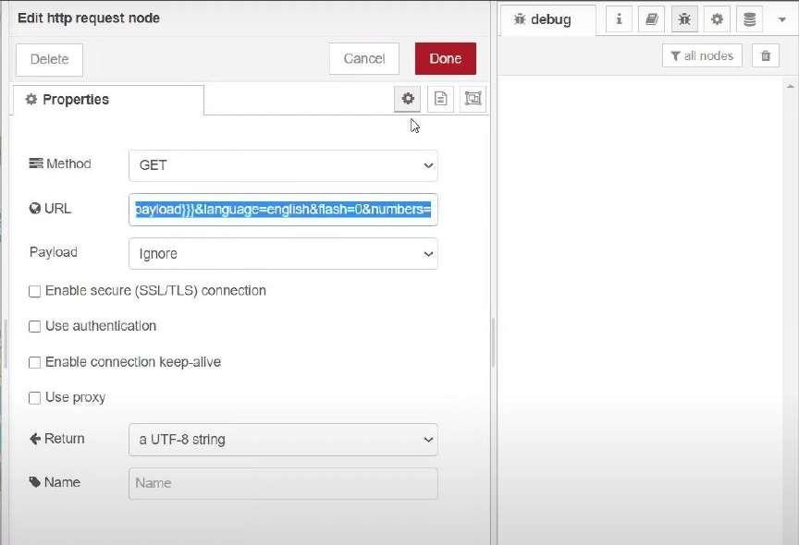

1. Locate the child

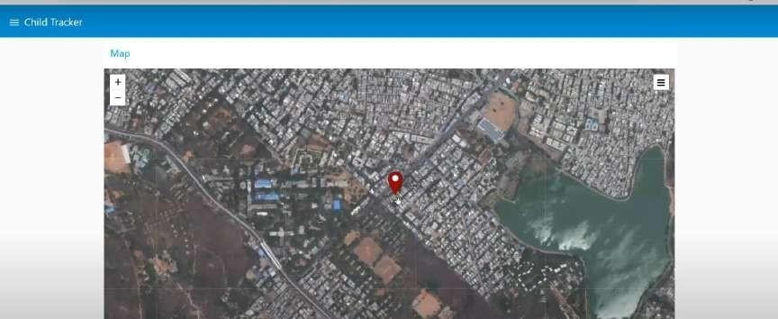

1. Create the geofence node

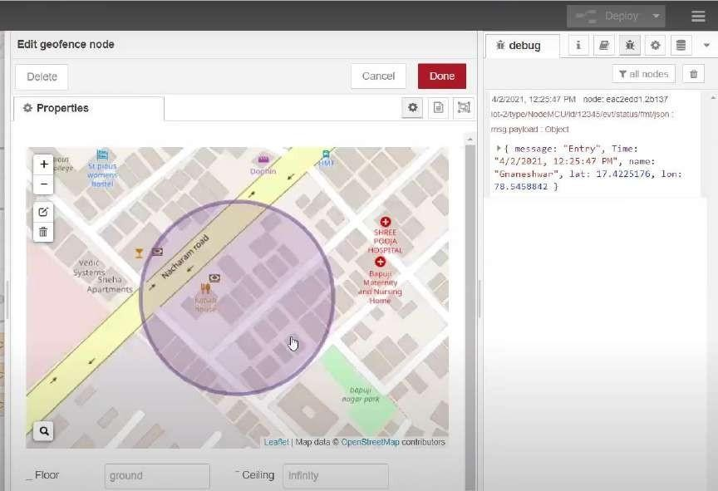

1. Python script send requests to IBM Cloud

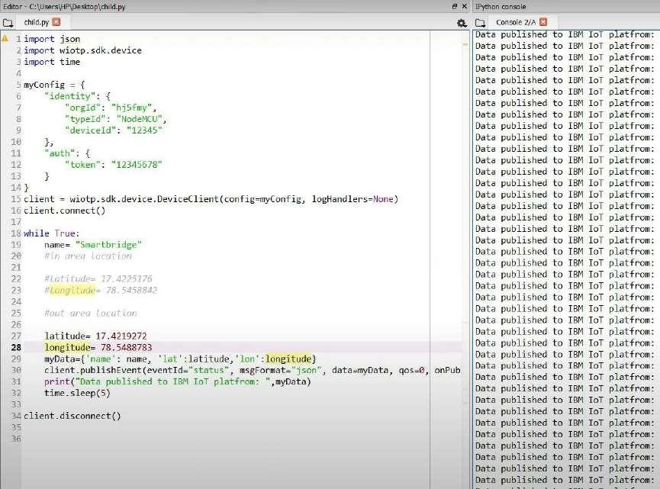

1. After running the script, the web UI shows “Person is not in the particular area”

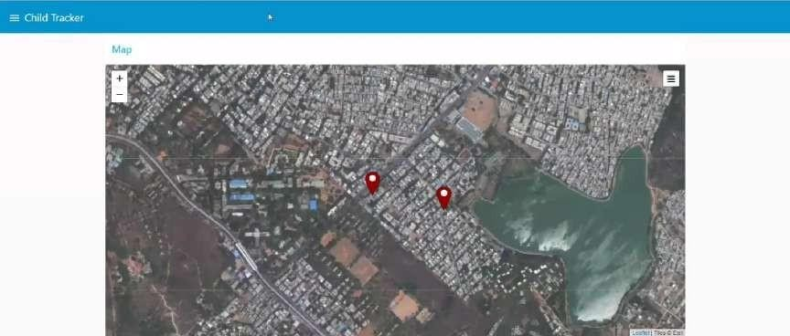

# Conclusion:

Developed the web application using Node-RED Successfully